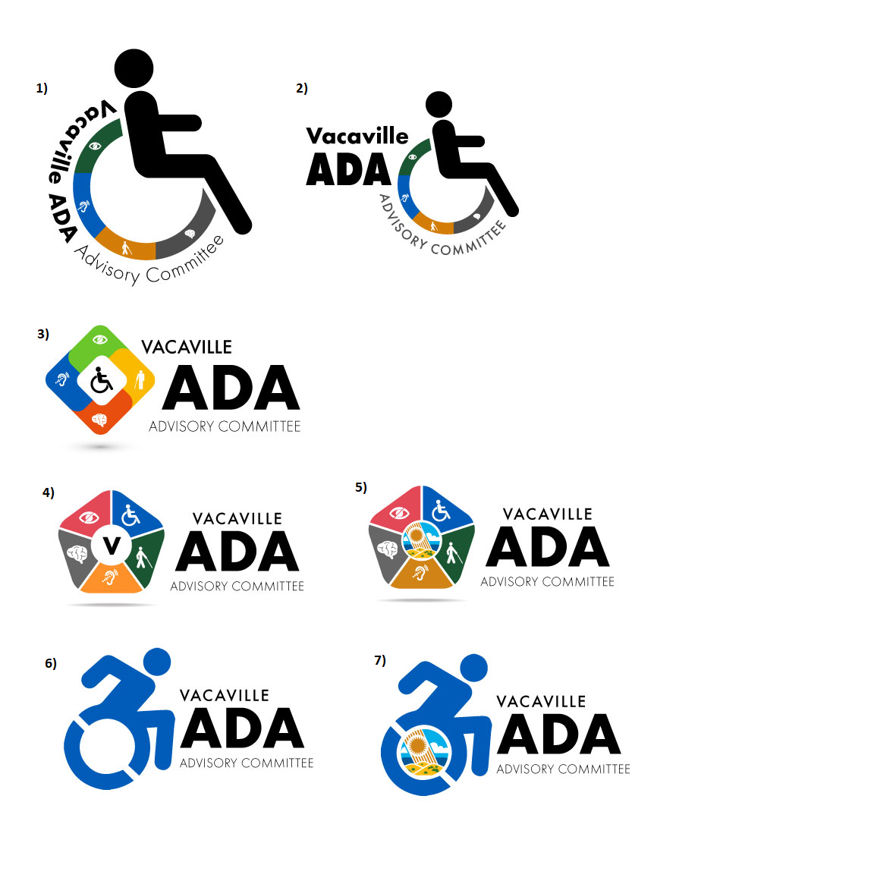

**ADA ADVISORY COMMITTEE AGENDA**

**-SPECIAL MEETING-**

**September 6, 2023 - 1:30 p.m.**

**In Person:**

**Vacaville City Hall, Public Works Conference Room #2**

**Zoom Meeting Information:**

**<https://cov.zoom.us/j/84611656284?pwd=Z1h4a21VV1U2aUpxYzdGK09VN0dndz09>**

**Meeting ID: 846 1165 6284**

**Passcode: 862824**

1. **INTRODUCTIONS AND ROLL CALL**
2. **APPROVAL OF MINUTES**
3. July 26, 2023
4. **NEW ITEMS**
5. Receive a presentation on the Vaca Valley/I-505 Multimodal Improvements by Interwest Group
   1. Consider submittal of a Letter of Support for the project.
6. **PROJECT LIST**
7. Current
   1. Project Completed: N. Orchard at Gonzales (3 ramps)
   2. Project Completed: Davis at Danfield (2 ramps)
   3. Project Completed: Alamo at Buck (2 ramps on the east side)
8. Prioritized
   1. Alamo at Buck (Alamo Park)
      1. West curb ramps are scheduled for summer 2024
   2. Danfield at Devonshire (2 ramps)
      1. Scheduled for summer 2024
9. Projects Under Consideration
   1. PENDING: New Request from Resident:
      1. Sierra Peak Way @ Pioneer Ct. (attachment 3)
10. Current Requests not Prioritized
    1. Sierra Peak Way @ Pioneer Ct.
11. **BUDGET UPDATE**

|  |  |  |  |  |
| --- | --- | --- | --- | --- |
| **Item** | **Revenue** | **Encumbrances** | **Actual Expenses** | **Total** |
| *Carryover Balance* |  |  |  | *$23,410.25* |
| FY 2023-24 Allocation | $50,000.00 |  |  | $73,410.25 |
| N. Orchard @ Gonzales (July 2023) |  |  | $(33,120.00) | $40,290.25 |
| **Subtotal** | **$50,000.00** | **$0.00** | **$(33,120.00)** | **$40,290.25** |
| Emergency Reserve |  | $(20,000.00) |  | $20,290.25 |
| **Total Available** |  |  |  | **$20,290.25** |

The total fund balance as of September 6, 2023 is $40,290.25. Of this amount, a reserve of $20,000 is earmarked for emergency and/or critical projects, leaving $20,290.25 available for projects.

1. **COMMUNITY MINUTE AND MEMBER UPDATES**
2. **NEXT MEETING**
3. The next regularly scheduled meeting is Wednesday, September 27, 2023 at 1:30 p.m.